**Project Name:** Buyer’s Document Progress Tracker­­

**Company Name:** SOC Land Development Corporation

**Project Duration:** May 29, 2017 – June 29, 2017

**Project Supervisor:** Yasmin Dela Cruz / Carla Joy Diva

**Platform: HTML, CSS, Php, Javascript, MySQL (XAMPP)­**

**Statement of the Problem**

There is an existing system that is being used for monitoring the progress of buyers Condominium Certificate of Title (CCT) Transfer from Company to Buyer. The system was built from Microsoft Excel using the table to identify their status.

The Sales Documentation Department uses this system as their tracking and monitoring system. They encountered some problem regarding to the usability of the system:

* Not fast to access the data within the Excel
* Different sheets/workbooks are being used in each phase of buyer’s progress
* Data are not protected from changes/updates while viewing
* Cannot be used by the other user (read only)
* No real-time update of the system
* No centralized database

**Process Flowchart** (see on page 4)

Process Flow for Condominium Certificate of Title (CCT) Transfer from Company to Buyer

1. The process of CCT transfer would start upon receiving the documents (buyer’s folder) from the Sales and Documentation Department (SLAD).
2. Review all the documents contained in the buyer’s folder. Checking for completeness of documents necessary for the transfer. The documents needed for the transfer would be as follows:
   1. Deed of Absolute Sale (DOAS) duly signed by the buyers and authorized representative of the company.
   2. Notarized Contract to Sell (CTS)
   3. Valid IDs of buyer’s, BIR TIN IDs
   4. Photocopy of Condominium Certificate of Title (CCT)
   5. Photocopy of Tax Declaration
   6. BIR Form 1606 and official receipt for the payment of CWT
   7. BIR Form 1701-E (Application for Registration)
   8. Official receipts as to the payment of the D/P and monthly amortization in support of the payment of the CWT, 25% of the total TSP.
   9. Photocopy of the License to Sell (LS) and Certificate of Registration (CR)
   10. Secretary’s Certificate authorizing signatory to sign in behalf of the company
3. Secure all the required certified true copies (CTC of CCT, tax declarations, and tax clearance certificates) from RD, Assessor’s Off. and Treasurer’s Off. respectively.
4. Compute all the necessary fees, documentary stamp tax (DST) on sale, transfer tax, RD filing fees and miscellaneous expenses by accomplishing the “Schedule of Registration Expenses”.
5. Proceed in requesting the “Request for Payment” (RFP) for all the registration fees. Have the schedule for registration expenses attached for reference.
6. Have the RFPs reviewed, checked and approve by immediate approving officer.
7. Secure a control no. from the accounting department by registering the RFPs in the “Accounting RFP Control Log Book”.
8. Reflect the control no. to each and every RFP made.
9. Register all RFPs made from the logbook of Management and Project Services Dept. log book and have the RFPs and log book received by the Accounting Dept. (Accounts Payable Officer)
10. Release of requested payments would be on the following Friday of the request. Have an allowance of 10 days for the processing of checks.
11. Follow-up release of checks from the cashier.
12. Request for the original Owner’s Duplicate copy of Condominium Certificate of Title from the title/document custodian for use of the original tct for BIR, transfer tax and Registry of Deeds.
13. Have the Deed of Absolute Sale notarized providing ample time for check processing. Payments of DST on sale would be on the 5th day of every month.
14. Collate all requirements for BIR processing of Certificate Authorizing Registration (CAR), transfer tax payment with the City Treasurer’s Office. Also accomplish the BIR form 2000 OT.
15. Present all the required documents to the Officer of the{ Day (OD) of the ONETT section of the Bureau of Internal Revenue.
16. Secure the Computation sheet from the OD. Check the amount if it is the same with the check requested.
17. If the amount is the same, proceed to the bank or BIR payment collection section and have the DST due paid. Payments for the documentary stamp on sale must be paid on or before the 5th day of the following month from the date of notarization.
18. Photocopy the Official Receipt (OR) of DST payment (2 copies), one for submission to BIR and one for liquidation/file.
19. Secure the one-time TIN for the buyer, attached the BIR form 1904 with all the documents needed in securing the Certificate of Registration.
20. Secure a Certificate fee and a Php 15.00 documentary stamp tax.
21. Submit all the BIR requirements to the receiving clerk of the ONETT Section of the BIR. Note: TIN no. of the vendee and vendor must be indicated on the BIR Return forms. BIR Form 1904 must be stamped verified by the TIN verifier of the ONETT section.
22. A claim stub would be issued after the application documents were received and found complete for processing.
23. Have a follow-up of status/lacking or deficiency in requirements and for CAR release on the date reflected on the claim stub.
24. Pay the transfer tax to the City Treasurer’s Office. Transfer tax payments must not go beyond the 60 day period from the time the Deed of Absolute Sale was notarized.
25. Once the CAR is released from the releasing clerk of the ONETT section of the BIR and the transfer tax was paid to the City Treasurer’s Office, collate all the requirements needed for submission to the Registry of Deeds – Taguig for CCT transfer to the buyer. Application of CCT transfer must be accompanied by an identification card (ID) of the presentor and RD Application Request Letter. CAR release would include the original DOAS submitted, BIR tax payment certification.
26. Present all the RD requirements to the entry clerk of the Registry of Deeds for application entry registration.
27. An accomplished RIO Assessment Form reflecting the total amount of RD fees would be issued by the entry clerk. The RIO Assessment has a validity of 3 days from date of issuance. Failure to pay or settle the filing fee would need another entry and assessment form.
28. Pay all the required RD filing fees to the Cashier section of the RD. The RD would issue an official receipt in which a corresponding EPEB # would be designated for the particular transaction. The EPEB # would be used as reference to follow-up the status of the application.
29. After the payment of RD filing fees, the application documents would be forwarded/routed to the RD chief (for assignment), to the examiner (for examination/checking), to the records section (for verification of RD CCT file), to the typist and uploader (for issuance of forms and uploading of the application/CCT transfter to the LRA system).
30. After a new CCT was issued in the name of the buyer, the CCT and all the documents would be forwarded to the RD chief for signing and approval.
31. Transferred CCT would be released by the releasing clerk of the RD. Documents to be released would be original owner’s copy of CCT, Deed of Absolute Sale, and duplicate/photocopies of transfer tax receipt, real property tax official receipts, BIR payments, tax declaration, CAR.
32. Have all the data on the CCT checked for errors. If there would be errors or discrepancies in the newly issued CCT, an affidavit attesting to the corrections would be executed and filed with the RD for annotation on the CCT issued. Corrections would only be annotated and not directly changed in the phase of the CCT.
33. Secure a certified true copy of the newly transferred CCT to be used for in the transfer of the Tax Declaration in to the buyer’s name. Certified true copies of newly transacted issuance/release could be secured after 3 to 5 days from the time the CCT was released.
34. Creditable withholding taxes (CWT) and documentary stamp tax (DST) in sale, photocopy of transfer tax payment, photocopy of the Condominium Certificate of Title, Copy of the Deed of Absolute Sale (DOAS) preferably with the stamped marked of the Registry of Deeds and the City Treasurer’s Office and current real property tax OR or RPT tax clearances.
35. Forward the said requirements to the City Assessor’s Office for the Transfer of Tax Declaration application to the name of the buyer.
36. Payment of a Php 200.00 filing fee would be due to the City Treasurer for the processing of the transfer of tax declaration.
37. Processing time for the Tax Declaration Transfer would be 3 to 5 days for single transaction or would go beyond if filed on a bulk basis.
38. Have the Tax Declaration in the name of the buyer checked for errors especially the name of the buyer, the address and the unit details (unit no., area, CCT no.)
39. All the photocopies of the documents secured from BIR (CAR, DST, OR, BIR Form 1904 – TIN verification, Tax Clearance Certificate), Treasurer’s Off. (Transfer tax receipt, real property tax clearance/updated RPT OR), RD (CCT – buyer’s name, DOAS), Assessor’s Office (Tax Declaration – buyer’s name) would be attached inside the buyer’s folder.
40. The buyer’s folder together with all the documents secured would be returned to the SLAD for safekeeping.

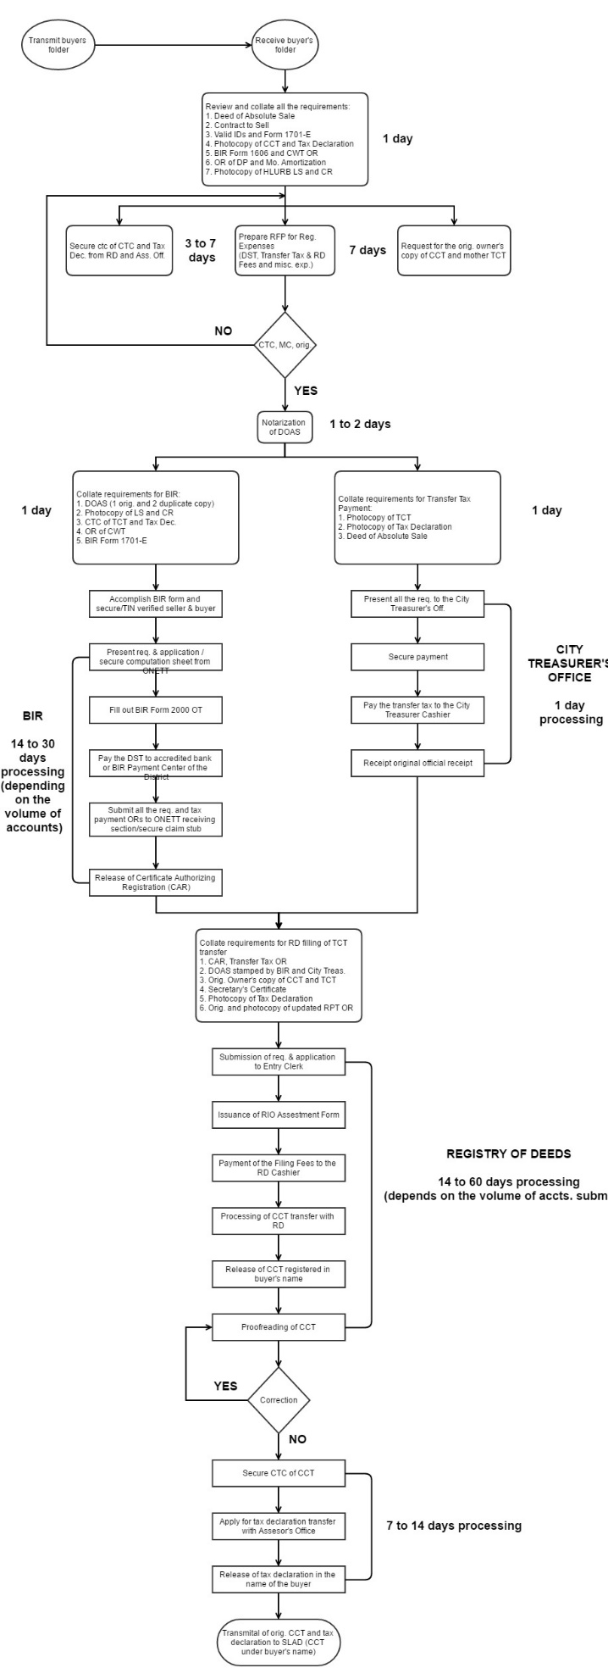

Server specs:

Interview with the client:

Q: How long are you using the existing system?

Q: Is there any other system that you are using for monitoring?

Q: What are the problems that you usually encounter?

Q: What are your expecting outputs for the new system?

A: Report Generation of the following:

1. No. of status of lot: ‘A’ – Available, ‘R’ – Reserved, ‘HS’ - Hold for Sale, ‘H’ – Hold
2. No. of unit type: ‘S’ – Studio (not finished, need to gather data for Unit/Bldg.)
3. No. of cancelled accounts: ‘T’ – Transferred, ‘R’ – Reserved, ‘C’ – Cancelled, ‘H’ – Hold
4. No. of status of client CTS: ‘I’ – In-transit, ‘M’ – Mancom Signature, ‘N’ – Notarized, ‘C’ – Complete, ‘L’ – Lacking
5. Documents needed to pass for CTC: